**CC-LAB MID**

**Submitted By: Talha Azeem**

**Reg No: Sp20-Bcs-047**

**Submitted To: Bilal Bukhari**

**Date: 05-04-2024**

**Question 1:** Briefly describe the regex library of C#?

Answer: The regex library in C# provides a robust set of classes and methods for working with regular expressions. It is part of the .NET framework's System.Text.RegularExpressions namespace. Here's a brief overview of its features:

1. **Regex Class**: The Regex class is the primary entry point for working with regular expressions in C#. It provides methods for compiling regular expressions, matching input strings against patterns, and replacing occurrences of patterns in input strings.
2. **Pattern Syntax**: The library supports standard regular expression syntax, including metacharacters for specifying patterns, quantifiers for repetition, character classes, groups, and more.
3. **Match Object**: When a regex pattern matches a portion of an input string, it creates a Match object containing information about the match, such as the matched text, its index in the input string, and any captured groups.
4. **Grouping and Capturing**: Regular expressions can define groups within patterns using parentheses. These groups can be captured separately during matching, allowing access to specific parts of the matched text.
5. **Replacement**: The Regex class provides methods for replacing matched patterns in input strings with specified replacement text. It supports placeholders for referencing captured groups in the replacement text.
6. **Options and Modifiers**: Various options and modifiers can be applied to regex patterns to control matching behavior, such as case sensitivity, multiline mode, and single-line mode.
7. **Performance Optimization**: The library includes features for optimizing regex performance, such as compiled regex patterns that are cached for reuse across multiple matches.

**Question 3:** Make a Password generator according the following rules:

* Atleast one uppercase alphabet
* Atleast 4 numbers , two numbers must be your registration numbers
* Atleast 2 special characters
* Must contain initials of first and last name
* Must contain all odd letters of your first name.
* Must contain all even letters of your last name.

Answer:

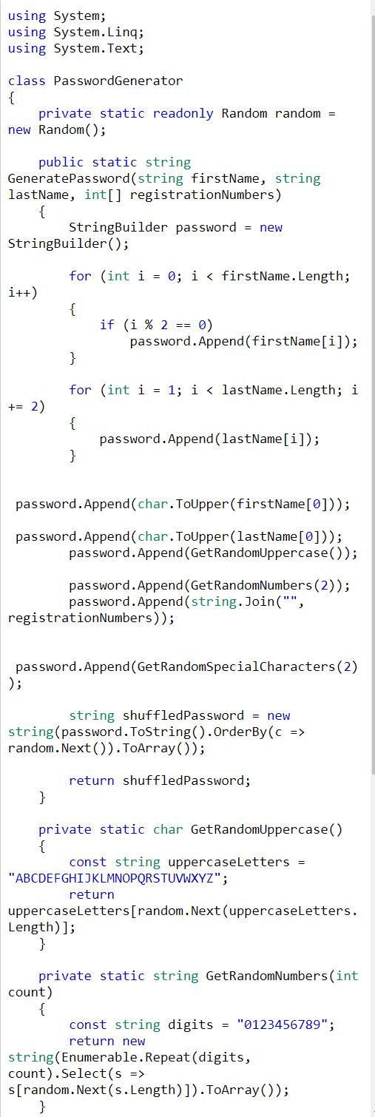

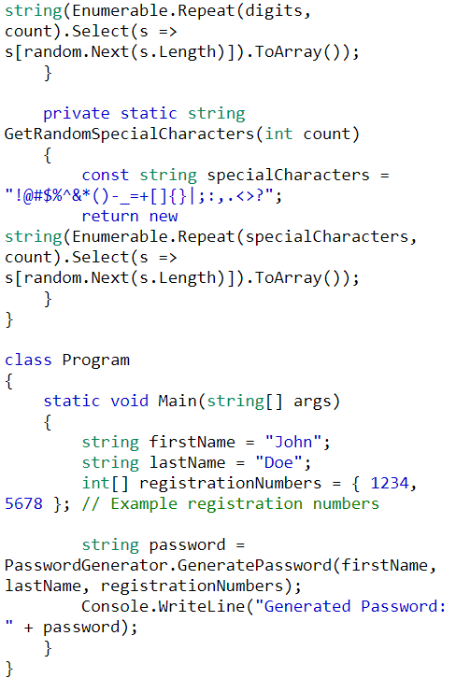

**Output:**

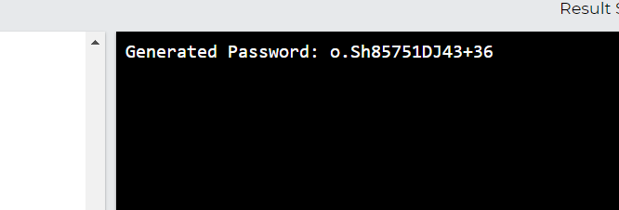

Code Of Question 3:

using System;

using System.Linq;

using System.Text;

class PasswordGenerator

{

private static readonly Random random = new Random();

public static string GeneratePassword(string firstName, string lastName, int[] registrationNumbers)

{

StringBuilder password = new StringBuilder();

for (int i = 0; i < firstName.Length; i++)

{

if (i % 2 == 0)

password.Append(firstName[i]);

}

for (int i = 1; i < lastName.Length; i += 2)

{

password.Append(lastName[i]);

}

password.Append(char.ToUpper(firstName[0]));

password.Append(char.ToUpper(lastName[0]));

password.Append(GetRandomUppercase());

password.Append(GetRandomNumbers(2));

password.Append(string.Join("", registrationNumbers));

password.Append(GetRandomSpecialCharacters(2));

string shuffledPassword = new string(password.ToString().OrderBy(c => random.Next()).ToArray());

return shuffledPassword;

}

private static char GetRandomUppercase()

{

const string uppercaseLetters = "ABCDEFGHIJKLMNOPQRSTUVWXYZ";

return uppercaseLetters[random.Next(uppercaseLetters.Length)];

}

private static string GetRandomNumbers(int count)

{

const string digits = "0123456789";

return new string(Enumerable.Repeat(digits, count).Select(s => s[random.Next(s.Length)]).ToArray());

}

private static string GetRandomSpecialCharacters(int count)

{

const string specialCharacters = "!@#$%^&*()-_=+[]{}|;:,.<>?";

return new string(Enumerable.Repeat(specialCharacters, count).Select(s => s[random.Next(s.Length)]).ToArray());

}}

class Program

{

static void Main(string[] args)

{

string firstName = "John";

string lastName = "Doe";

int[] registrationNumbers = { 1234, 5678 }; // Example registration numbers

string password = PasswordGenerator.GeneratePassword(firstName, lastName, registrationNumbers);

Console.WriteLine("Generated Password: " + password);

}

}

**Question 2:** Make recursive descent or LL1 parser or recursive descent parser for the following grammar:

S -> X$

X -> X % Y |Y

Y -> Y & Z |Z

Z -> k X k | g

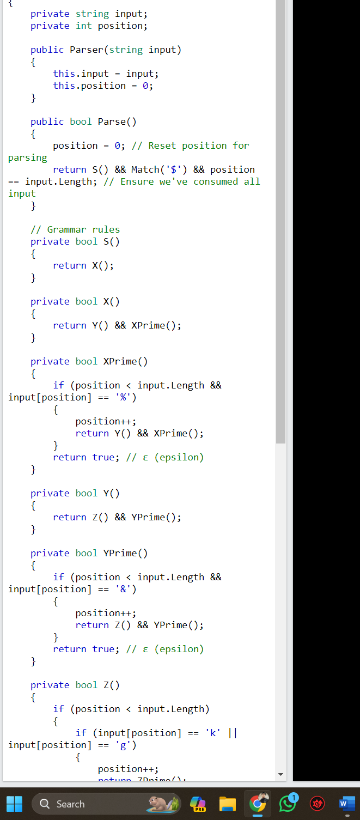

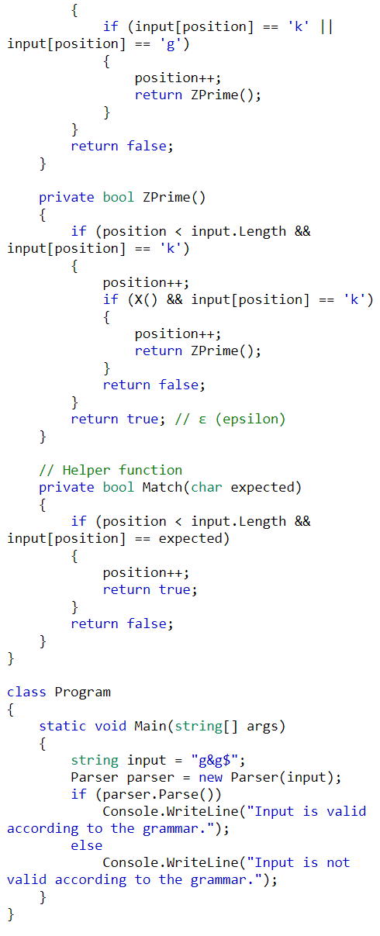

**Code:**

using System;

class Parser

{

private string input;

private int position;

public Parser(string input)

{

this.input = input;

this.position = 0;

}

public bool Parse()

{

position = 0; // Reset position for parsing

return S() && Match('$') && position == input.Length; // Ensure we've consumed all input

}

private bool S()

{

return X();

}

private bool X()

{

return Y() && XPrime();

}

private bool XPrime()

{

if (position < input.Length && input[position] == '%')

{

position++;

return Y() && XPrime();

}

return true; // ε (epsilon)

}

private bool Y()

{

return Z() && YPrime();

}

private bool YPrime()

{

if (position < input.Length && input[position] == '&')

{

position++;

return Z() && YPrime();

}

return true; // ε (epsilon)

}

private bool Z()

{

if (position < input.Length)

{

if (input[position] == 'k' || input[position] == 'g')

{

position++;

return ZPrime();

}

}

return false;

}

private bool ZPrime()

{

if (position < input.Length && input[position] == 'k')

{

position++;

if (X() && input[position] == 'k')

{

position++;

return ZPrime();

}

return false;

}

return true; // ε (epsilon)

}

private bool Match(char expected)

{

if (position < input.Length && input[position] == expected)

{

position++;

return true;

}

return false;

}

}

class Program

{

static void Main(string[] args)

{

string input = "g&g$";

Parser parser = new Parser(input);

if (parser.Parse())

Console.WriteLine("Input is valid according to the grammar.");

else

Console.WriteLine("Input is not valid according to the grammar.");

}}